HRSBDC WORKSHOPS 2020

+++++++++++++++++++++++++++++++++++++++++++++++++++++++++++++++++++++++++++++++++++++++++++++++++++++++++++++++
Do You Own a Small Business?
What’s Your Question(s)?
The HRSBDC Representatives ARE HERE TO ASSIST
February 27, 2020
9:00 a.m. – 1:00 p.m. (Doors open at 8:15 a.m.)
This session is in place to share information on “Taking an Existing Business to the Next Level! JOIN ME! I will share information on how to take an existing business to the next level; and, dependent on your questions, share resources to allow you to move forward with your research.
Room #1117
+++++++++++++++++++++++++++++++++++++++++++++++++++++++++++++++++++++++++++++++++++++++++++++++++++++++++++++++
“It’s All About Loans”
Come Help the HRSBDC Celebrate
The National SBDCDay!

March 18th
8:00 a.m. – 3:00 p.m. (Doors open at 7:30 a.m.)
Conference Room #s1301-1303

Come learn how to prepare to apply for a loan and the various types of business loans!
Meet Lenders; Commissioner of Revenue; Department of Labor; Department of Economic Development Representatives, and much more!

Free (Absolutely No Walk-ins) Must pre-register by March 16th
+++++++++++++++++++++++++++++++++++++++++++++++++++++++++++++++++++++++++++++++++++++++++++++++++++++++++++++++
Managing Your Personal and Business Credit
March 26; June 25; September 17
9:00 a.m. – 12:00 p.m. (Doors open at 8:15 a.m.) Room #1118
It costs money to start a business. This workshop offers a wide range of helpful information to help you reach your financial goals and make the right choices to fund the business. With a better understanding of how lenders view and assess your company’s creditworthiness, you’ll be better prepared to obtain the funding you need to grow and thrive.
+++++++++++++++++++++++++++++++++++++++++++++++++++++++++++++++++++++++++++++++++++++++++++++++++++++++++++++++
How to do Business with the State of Virginia Using eVA
May 28; August 27; November 19
09:00 a.m. – 12:00 p.m. (Doors open at 8:15 a.m.) Room #1118
Each year, the Commonwealth of Virginia spends more than $8 billion on goods and services - goods and services that you probably sell! Are you getting your share? Most contract requests are published through eVA, Virginia’s eProcurement portal. In this session, a representative from the Virginia Department of Small Business and Supplier Diversity (SBSD) will walk you through the understanding of eVA. Topics to be covered include:
* What is eVA? * Purchasing in the Commonwealth * Vendor's Manual * Small Purchase Policy * eVA Tools * A Vendor’s Perspective * How buyers use the eVA system to “shop” * Navigating eVA’s Free Public Reports *
+++++++++++++++++++++++++++++++++++++++++++++++++++++++++++++++++++++++++++++++++++++++++++++++++++++++++++++++
SWaM Certification Session
April 23; July 30; October 29
9:00 a.m. – 12:00 p.m. (Doors open at 8:15 a.m.) Computer Lab #1113
Are you a small, woman or minority-owned business (SWaM)? Small business owners who are looking to participate in Virginia’s specialized procurement and contracting opportunities are encouraged to become SWaM certified. SWaM certification is a State program establish to promote economic growth of Virginia’s businesses.
In this “Hands On” workshop session you will create your account, receive assistance with uploading REQUIRED documents and get answers to any questions you may have. SBSD staff will be on-site to assist.
++++++++++++++++++++++++++++++++++++++++++++++++++++++++++++++++++++++++++++++++++++++++++++++++++++++++++++
All are Free Events (No Walk-ins-Must Pre-register) and will be held at the:
Peninsula Workforce Development Center * 600 Butler Farm Road * Hampton VA 23666
For more information, please contact 757-825-4079 gonsalvest@tncc.edu
To register for any of these events, please visit the Hampton Roads Chamber Calendar of Events
http://www.hamptonroadschamber.com then click the date
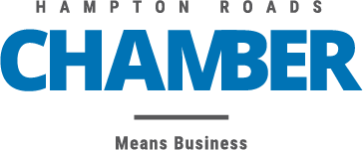
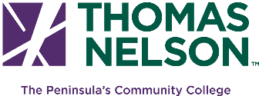
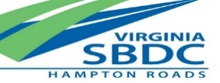
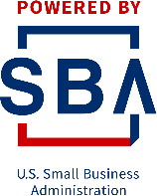

Funded in part through a cooperative agreement with the U.S. Small Business Administration. Opinion, conclusions or recommendations expressed are those of the author(s)/presenter(s) and do not necessarily reflect the views of the SBA.

