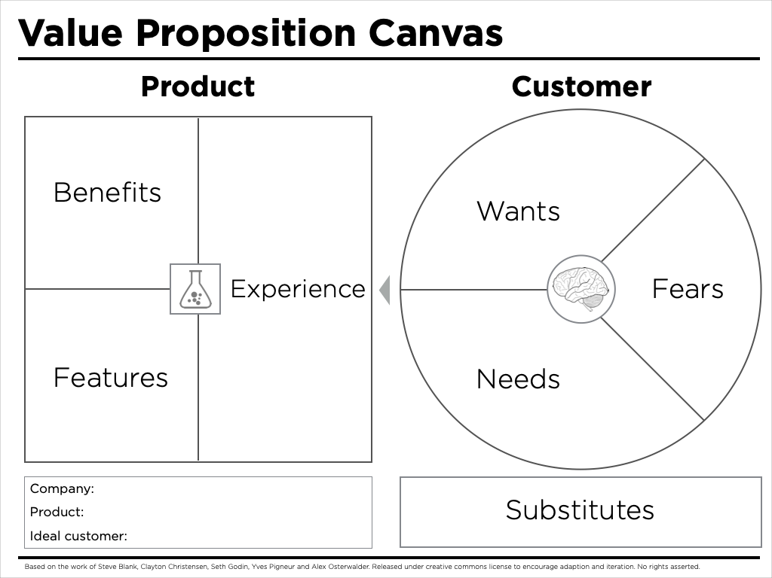

Company Name | Founder(s) | Key Employees & Role

The purpose of this worksheet is to prepare you to create your company’s business model canvas by exploring what the product - market fit might be.

Customer
Describe the customer segment and sub segments that are your intended targets; ask yourselF, “how would I find them?” ; You may need to create a fictitious “avatar” or “Persona” for each sub segmented intended targeted customer segment you envision

Substitutes / Competitors
What would your target customer do if they did not buy your PRODUCT or SERVICE, and what are the shortcomings of that solution (FUD)? Who (specifically) would they buy from (Name the Competitor's website)
Describe the substitute / Identify Competitive URLs | List the main Shortcoming (Basis for FUD)

Customer Fears
What are the risks of switching to your PRODUCT or SERVICE?

Customer Needs
What are the rational drivers of purchase?

What are the hidden needs?

Customer Wants
What are the emotional drivers of purchase?

PRODUCTs or SERVICEs
What would your customer call your PRODUCT or SERVICE? What specific and tangible products or services are they paying money for? Be VERY Specific

Experience
What does it feel like to use your PRODUCT or SERVICE?
- 1

Benefits
How specifically do your intended customers gain utility value beyond the price point of your product or service? What tangible, measurable benefits do they achieve? (quantify if possible)

Features
How does your PRODUCT or SERVICE work?

FUD is Fear, Uncertainty and Doubt. Meaning what is the substitute’s shortcoming you think would encourage a review of alternative products or services?

