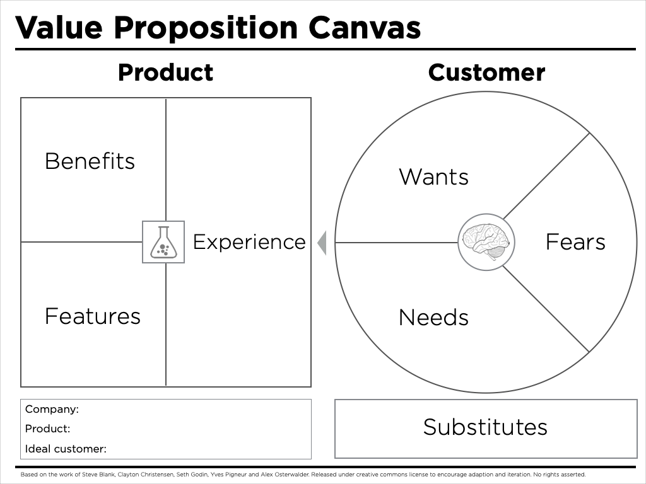

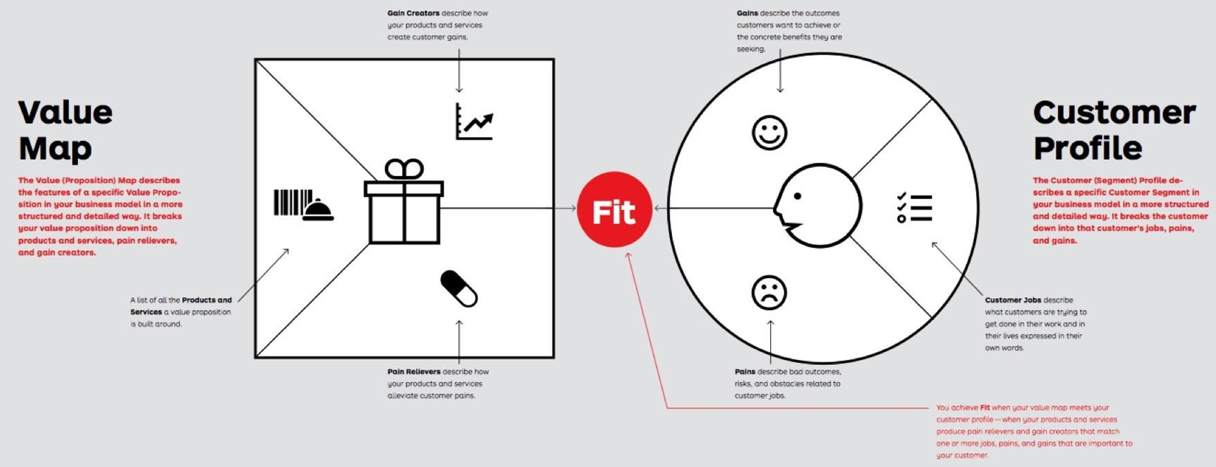

Company Name | Founder(s) | Key Employees & Role
Arena of Dreams

The purpose of this worksheet is to prepare you to create your company’s business model canvas by exploring what the product - market fit might be.

Substitutes
What would your target customer do if they did not buy your PRODUCT or SERVICE, and what are the shortcomings of that solution (FUD)?
Describe the substitute | List the main Shortcoming (Basis for FUD)

Fears
What are the risks of switching to your PRODUCT or SERVICE?

Needs
What are the rational drivers of purchase?

What are the hidden needs?

Wants
What are the emotional drivers of purchase?

Experience
What does it feel like to use your PRODUCT or SERVICE?

PRODUCT or SERVICE
What would your customer call your PRODUCT or SERVICE?

Customer
Describe the customer you are targeting

Benefits
What does your PRODUCT or SERVICE do?

Features
How does your PRODUCT or SERVICE work?

FUD is Fear, Uncertainty and Doubt. Meaning what is the substitute’s shortcoming you think would encourage a review of alternative products or services?

